KYRE PARK
DETAILED ITINERARY
3rd to 7th September 2023
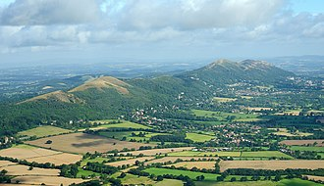

Sunday 3rd September
Guests arrive in time for tea at 3.30pm
7.00 Assemble in the Drawing Room to meet your fellow guests over a glass of champagne.
7.30 Dinner
Monday 4th
Continental Breakfast served from 7.30am
9.30 Assemble in the Schoolroom. Talk by John Beavan, Cabinet Maker. John is one of Britain’s outstanding cabinet makers with commissions from all over the world. See www.johnbeavan.com.
10.00 Depart for John Beavan’s workshop
12.00 Depart for Lunch (included) at Kyre Barn Bistro.
13.00 Free time; Suggested visit; Witley Court (English Heritage) and adjacent church (own transport) or discover the extensive landscaped grounds of Kyre Park.
13.30 Arrive Witley Court. Witley is the now ruinous mansion of the Earls of Dudley with gardens by Nesfield, the Victorian garden designer, centred on the astonishing Perseus and Andromeda fountain. Adjacent is the Baroque church with fittings from the destroyed palace of the Dukes of Chandos.
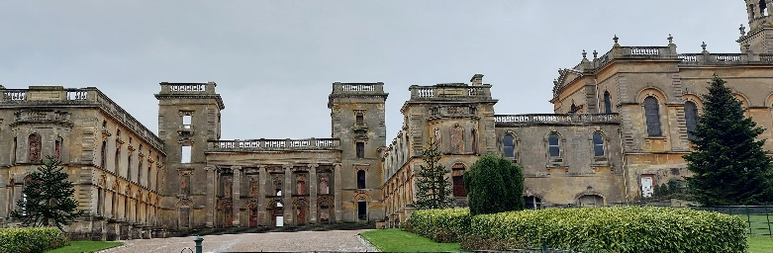
Free Time, Return to Kyre at your own convenience.
7.30 Dinner
Tuesday 5th
Continental Breakfast served from 7.30am
9.30 Assemble in Schoolroom to hear of today’s destinations
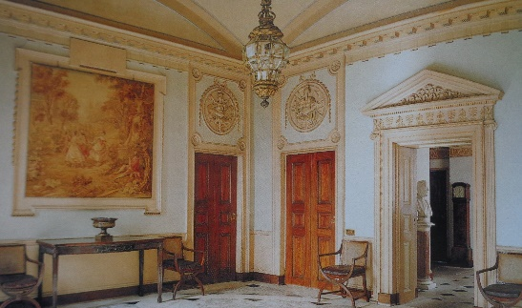
10.00 Depart by coach for Berrington Hall. Berrington is an 18th century Palladian mansion designed by Henry Holland, a favoured architect of the Prince Regent. Built in a distinctive red sandstone, the house displays the refined elegance for which the architect was famous.
12.30 Depart for Burton Court
13.00 Arrive Burton Court for lunch (included) followed by guided tour.
A manor house steeped in history over 900 years. The centrepiece of the house is a 14th Century Great Hall a remarkable survival of medieval architecture. The rest of the house is mainly from Regency time and the Eastern frontage was designed in 1911 by Sir Clough Williams-Ellis, the architect of Portmeirion fame. Depart 16.30
17.30 Arrive Kyre
19.30 Dinner
Wednesday 6th
Continental Breakfast served from 7.30am
9.00 Assemble in the Schoolroom. Talk by Nicholas on the today’s destination
10.00 Depart by coach for Perrycroft.
10.45 Arrive Perrycroft; The Arts and Crafts House of the Tour. Built by C F A Voysey, one of the principle apostles of the movement for the industrialist, J W Wilson, as in Albright and Wilson in 1895.
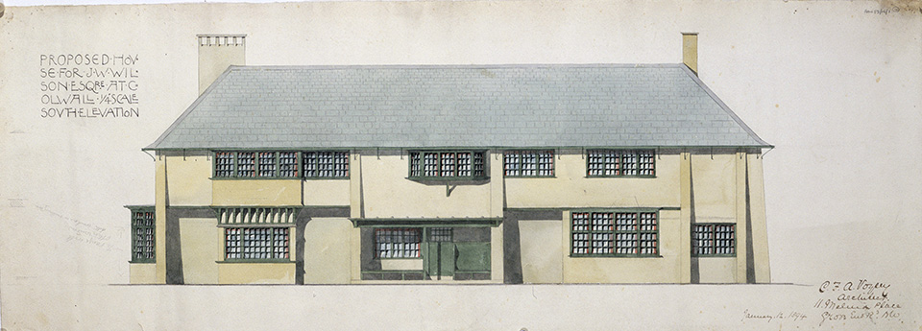
12.45 Depart Perrycroft
13.00 Lunch at Malvern Hills Hotel (included)
14.00 Depart for Sufton
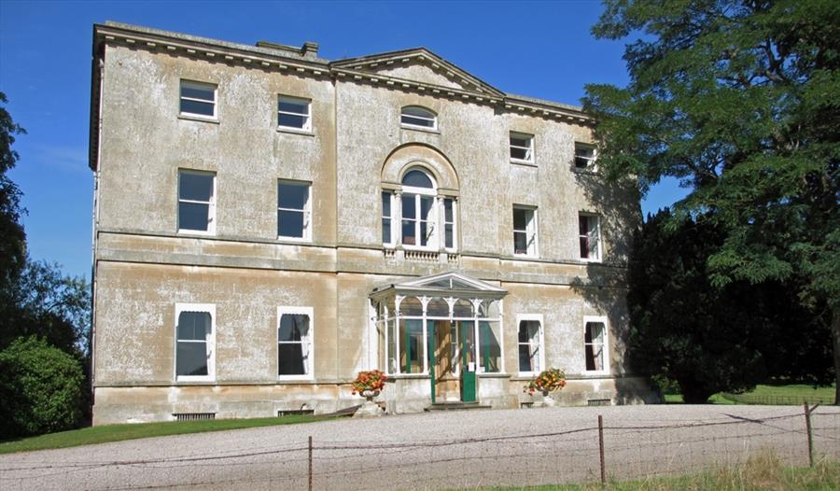
14.30 Sufton Court, the home since the 12th century, of the aptly named, Hereford family. This late 18th century house by James Wyatt commands spectacular views over the River Wye. The site inspired the family to commission Humphry Repton to landscape the park,and create one of his famous Red Books.
17.00 Depart Sufton.
17.45 Arrive Kyre.
19.30 Dinner
Thursday 7th. Guests depart after Breakfast

