BOOKING FORM

KYRE PARK, WORCESTERSHIRE.
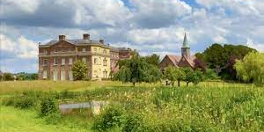

Please reserve ……… places on this holiday.
Cost £1500pp, 4 nights to include dinner, bed and breakfast, 3 lunches, entrance fees, transport, lectures by tour leader, Nicholas Merchant.
(Single supplement, £30 per night)

Please send a non-returnable deposit of £150 pp with your booking.

Final payment should be made on or before 1st August 2023.

Name……………………………………………………………………………………………………….

Address…………………………………………………………………………………………………….

……………………………………………………………………………………………………………….

……………………………………………………………………………………………………………….

Telephone………………………………………….Mobile……………………………………………….

Email…………………………………………………………………………………………………………

Signed……………………………………………………………………………………………………….

Please make payment to Aspect Events.

Barclays Bank

Sort code 20-37-13
Account Number 93073920.
Aspect Events

We look forward to you joining us.
Any queries, please contact
Nicholas Merchant
01423340017
merchantn@btconnect.com

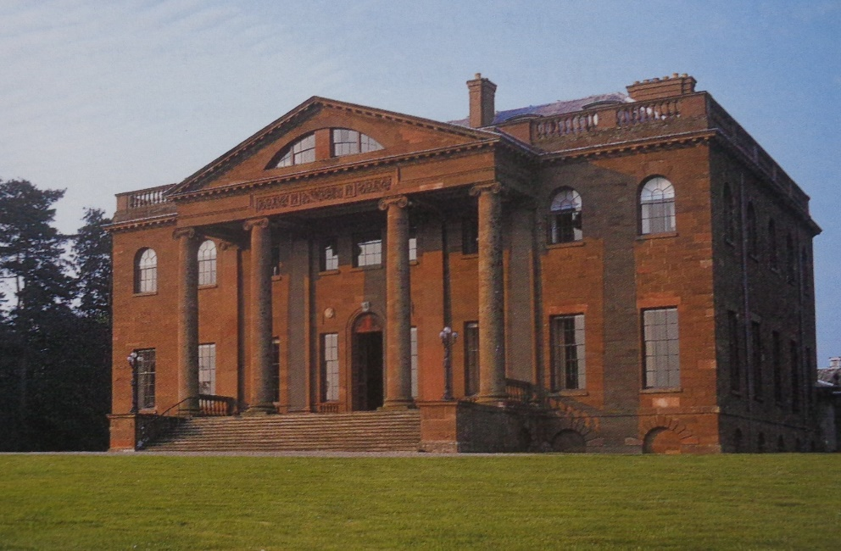
Berrington Hall

